**PIZZA SALES SQL QUERIES**

SELECT * FROM pizza_sales

**A)KPIs REQUIREMENT**

1):Total Rebvenue (The sum of total price of all orders.)

Select round(sum(total_price),2) as Total_Revenue

from pizza_sales;

output Total_Revenue = 817860.05

2): Average Order Value: (The average amount spent per order.

calculated by dividing the total revenue by the total number of orders.)

select round(sum(total_price) / count(distinct order_id) ,2) as Average_Order_Value

from pizza_sales;

output Average_Order_Value = 38.31

3): Total Pizza Sold:

( The Sum of the quantity of all pizzas sold)

select round(sum(quantity),2) as Total_Pizza_Sold

from pizza_sales;

Output Total_pizza_Sold = 49574

4):Total Orders:

(The total number of orders placed.)

select count( distinct order_id) as Total_Orders

from pizza_sales

Output Total_Orders = 21350

5): Average Pizzas Per Order:

The average number of pizzas sold per orders, calculated by dividing

the total number of pizzas sold by the total number of orders.

select (cast (cast(sum(quantity) as Decimal(10,2))/

cast(count(distinct order_id) as decimal(10,2)) as decimal(10,2))) AS Average_Pizzas_Per_Order

from pizza_sales

Output Average_Pizzas_Per_Order = 2.32;

**B) Daily Trend For Total Orders:**

select datename(DW, order_date) as order_day , count(distinct order_id) AS Total_Orders

from pizza_sales

group by datename(DW , order_date)

sort

select DATENAME( DW , order_date) As Order_Day , Count(distinct order_id) as Total_Orders

from pizza_sales

group by datename(DW, order_date) , datepart(DW, order_date)

order by datepart(DW, order_date)

**OUTPUT:**

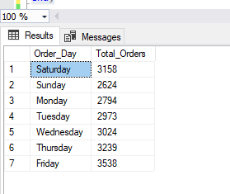

**C)Monthly Trend For Total Orders**

SELECT DATENAME(MONTH, order_date) AS order_month,

COUNT(DISTINCT order_id) AS Total_Orders

FROM pizza_sales

GROUP BY DATENAME(MONTH, order_date) , DATEPART(MONTH, order_date)

ORDER BY DATEPART(MONTH, order_date)

**OUTPUT:**

;

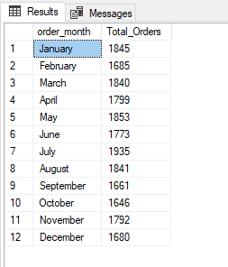

**D) Percentage of Sales By Pizza Category:**

SELECT pizza_category,

CAST(SUM(total_price) AS DECIMAL(10, 2)) AS total_revenue,

CONCAT(CAST((SUM(total_price) * 100 / (SELECT SUM(total_price) FROM pizza_sales where month(order_date) = 2)) AS DECIMAL(10, 2)) ,'%') AS PCT

FROM pizza_sales

where month(order_date) = 2

GROUP BY pizza_category;

**OUTPUT:**

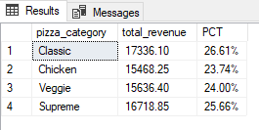

**E) % of Sales by Pizza Size**

select pizza_size,

cast(sum(total_price) as decimal(10,2)) as Total_Sales ,

concat(cast(sum(total_price) * 100 / (Select sum(total_price) from pizza_sales where month(order_date) = 2) as decimal(10,2)) , '%') AS PCT

From pizza_sales

where month(order_date) = 2

group by pizza_size

order by PCT Desc ;

**OUTPUT:**

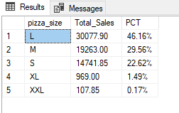

**F)Total Pizzas Sold by Pizza Category**

select pizza_category , sum(quantity) as Total_Quantity_Sold

from pizza_sales

--where month(order_date) = 2

group by pizza_category

order by Total_Quantity_Sold desc

OUTPUT:

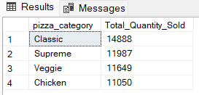

=============================

**G)Top 5 Pizzas by Revenue**

select top 5 pizza_name , sum(total_price) as Total_Revenue

from pizza_sales

group by pizza_name

order by Total_Revenue desc

OUTPUT:

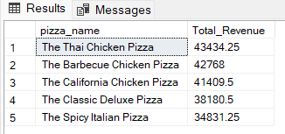

**H)Bottom 5 Pizzas by Revenue**

select top 5 pizza_name , sum(total_price) as Total_Revenue

from pizza_sales

group by pizza_name

order by Total_Revenue ASC

OUTPUT:

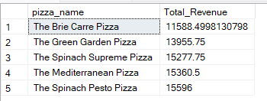

**I)Top 5 Pizzas by Quantity**

select top 5 pizza_name , sum(quantity) as Total_Pizza_Sold

from pizza_sales

group by pizza_name

order by Total_Pizza_Sold Desc

OUTPUT:

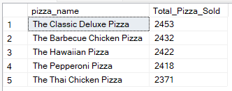

**J) Bottom 5 Pizzas by Quantity**

select top 5 pizza_name , sum(quantity) as Total_Pizza_Sold

from pizza_sales

group by pizza_name

order by Total_Pizza_Sold

OUTPUT:

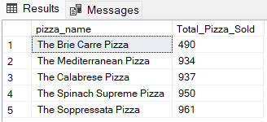

K) Top 5 Pizzas by Total Orders

select top 5 pizza_name ,count(distinct order_id) as Total_Orders

from pizza_sales

group by pizza_name

order by Total_Orders DESC

OUTPUT:

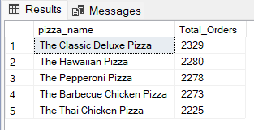

**L) Bottom 5 Pizzas by Total Orders**

select top 5 pizza_name , count(distinct order_id) as Total_Orders

from pizza_sales

group by pizza_name

order by Total_Orders

OUTPUT:

